Crop Deal:-

*Low Level Design (LLD)*

**Table of Contents**

***1.0 Document Purpose***

***2.0 Intended Audience***

***3.0 Project Background, Objective(s)***

***4.0 Design Pattern***

***5.0 Solution Steps***

***6.0 Classes/function name***

***7.0 Solution Diagram***

***8.0 Architecture Diagram***

***9.0 Er Diagram***

***10.0 Flow Diagram***

***11.0 Use Case Diagram***

***12.0 Class Diagram***

***13.0 Data Model/Tables***

**1.0 Document Purpose**

The documents contain a detailed description of the solution architecture of the Crop deal.

**2.0 Intended Audience**

|  |  |
| --- | --- |
| **Role Nature of Engagement in the Crop deal Architecture** | |
| **Product Owner/SME** | Key stakeholder to ensure that the architecture is aligned with business goals. |
| **Business Analysts** | Business analysts are one of the stakeholders who are informed with the key architectural decisions. |
| **Enterprise Architects** | To enforce Customer management Platform Architecture is  aligned to business goals and architecture, architectural guidelines. |
| **Developers** | Use Technical Architecture Document as the guiding document for detail design and implantation approach to  align with Customer management Microservice |
| **System Architects** | System architects are responsible for designing the overall system architecture, including how different modules and components interact with each other. |

* 1. **Project Background & Objectives**

# Project Background

The Crop Deal System is a comprehensive software solution designed to facilitate the buying and selling of agricultural crops between farmers and dealers. The system aims to streamline the crop transaction process, enhance transparency, and provide valuable insights to users in the agricultural sector. It is intended to bridge the gap between farmers looking to sell their produce and dealers seeking to purchase crops efficiently.

# Project Objectives

The objective of the Crop Deal System's Low-Level Design (LLD) phase is to architect and design a robust, secure, and scalable software solution that enables efficient crop transactions between farmers and dealers. This entails defining the system's technical architecture, database schema, user interfaces, and authentication mechanisms. Additionally, the LLD phase aims to ensure data security, optimize system performance, implement data analytics and reporting features, integrate external services such as payment gateways, and establish comprehensive testing, documentation, and compliance strategies.

**4.0 Design Pattern**

|  |  |  |
| --- | --- | --- |
| **Serial no. Name Description** | | |
| 1 | Angular | Creating a user interface (Front-end), and consuming API services. |
| 2 | Database | For storing, maintaining and accessing farmers, admin, crop dealers and crop deal details. |
| 3 | API | Using HTTP requests, we will use the respective action to trigger various  operations |

* 1. **Solution Steps**

# User Registration

1. The user will select their role as a farmer or dealer.

2. The user will enter the name, phone Number, Address and their bank account details during registration.

3. The input validation will be done.

a. If validation fails, then it will return the error code and error description.

with status code

b. If validation is successful, then the User details is stored in the database

and success code is sent.

## 5.2 Crop Listing

1. The Farmer will login using his username and password.

2. The Farmer will be posting all the available crops with the Name, quantity,

price for sale.

3. After posting all the details regarding the crops the farmer will be waiting for

the dealers.

# 5.3 Crops on Sale

1. The dealer logins with their username and password.

2. The dealer sees the all-listed crops that was listed by the various farmers.

3. When the dealer interested in purchasing the crops which was listed by the

farmer.

4. The Dealer will click proceed button

# 5.4 Payment

1. Then Dealer will reach the farmer location and checks the quality and weighs

the crops.

2. If the dealer is satisfied with the crop quality and the quantity.

3. He will again login using his login credentials and proceed with the payment.

4. After successful payment an Invoice will be generated and it will be sent to

both the farmer and Dealer.

**5.5 Admin Module**

1. Admin will login with his Username and Password.

2. Admin can able to filter active/inactive farmers and dealers.

3. The admin can get a Dealer’s report when he clicks to generate a particular

dealer report.

**6.0 Classes/Functions**

|  |  |  |
| --- | --- | --- |
| **Serial Class Description**  **no.** | | |
| **1** | Model Class | Model for holding the booking schema details for user. |
| **2** | Repository | The Interface in Data Access Layer for the user. |
| **3** | Controller | Controller handles the incoming HTTP requests and send the response back to the caller. |

|  |  |  |
| --- | --- | --- |
| **4** | Services | It’s the Business Access Layer holding the Business Logic and meditates the communication between the controller and repository (Data Access) Layer. |
| **5** | Exception Handlers | Exception Handlers handles all the exceptions that which are revealed during runtime. |

**7.0 Solution Diagram**

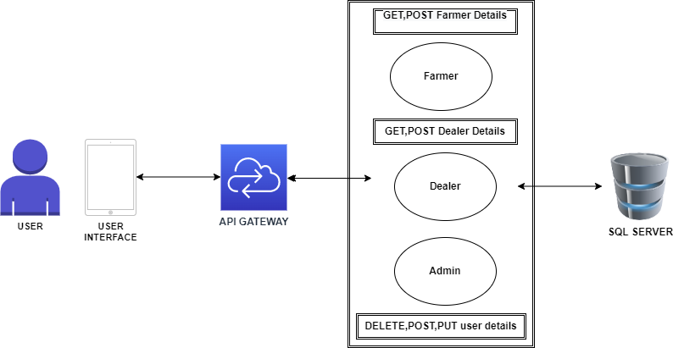

**8.0 Architecture Diagram**

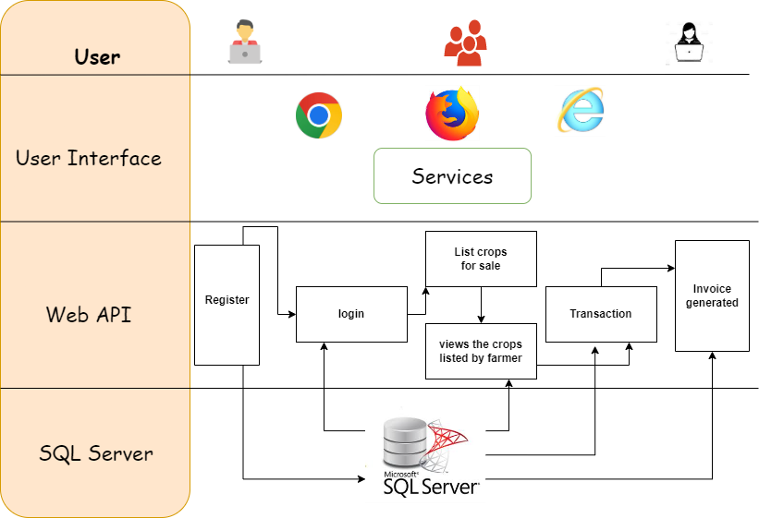

**9.0 Er Diagram**

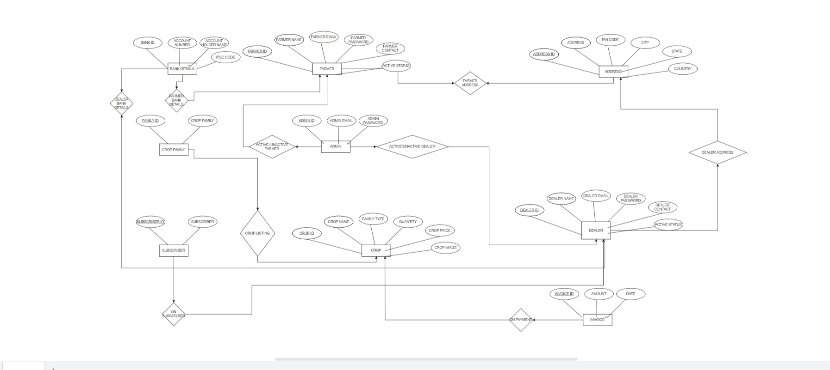

**10.0 Data Flow Diagram**

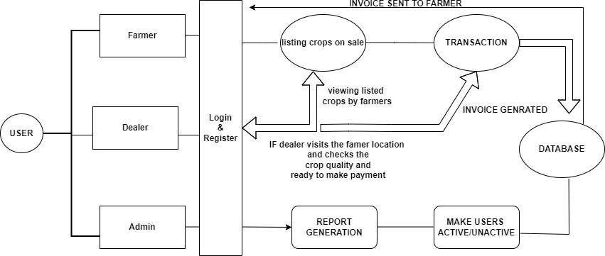

**11.0 Use Case Diagram**

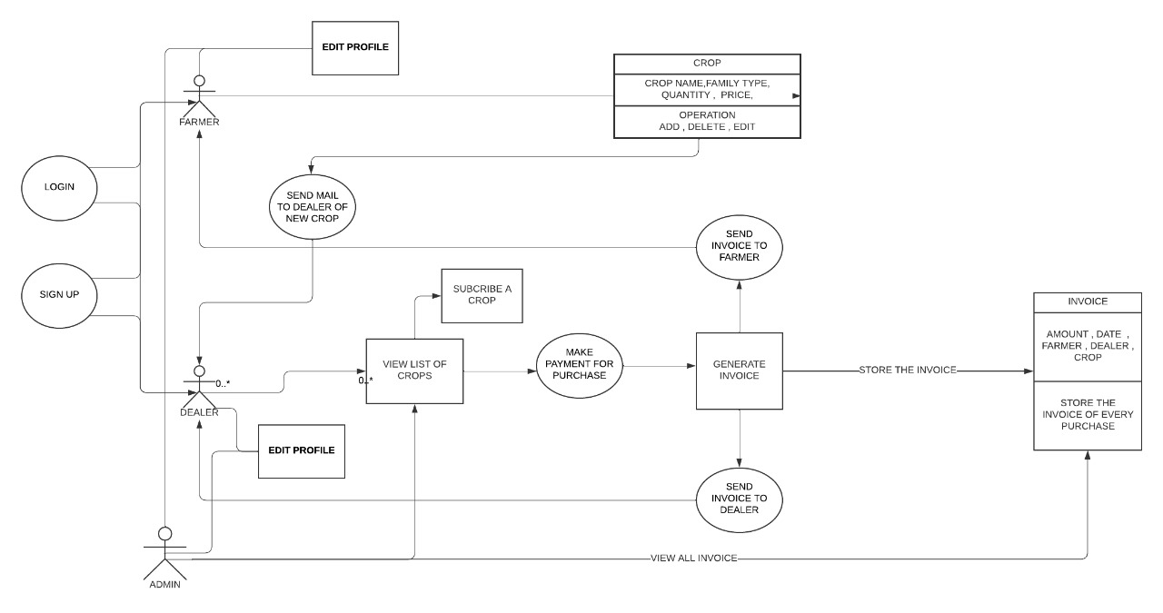

**12.0 Class Diagram**

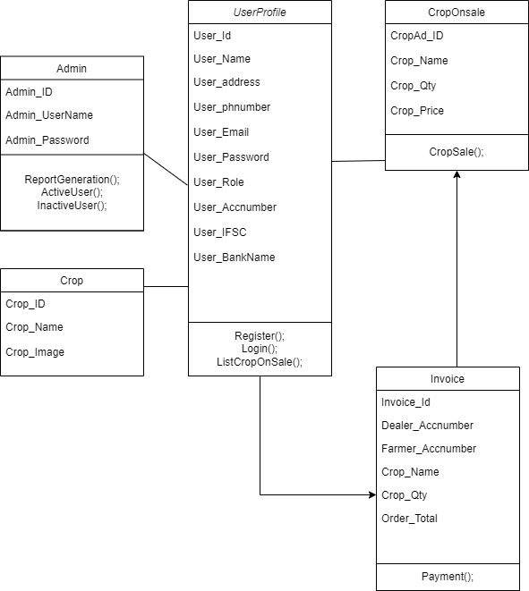

**13.0 Database Diagram**

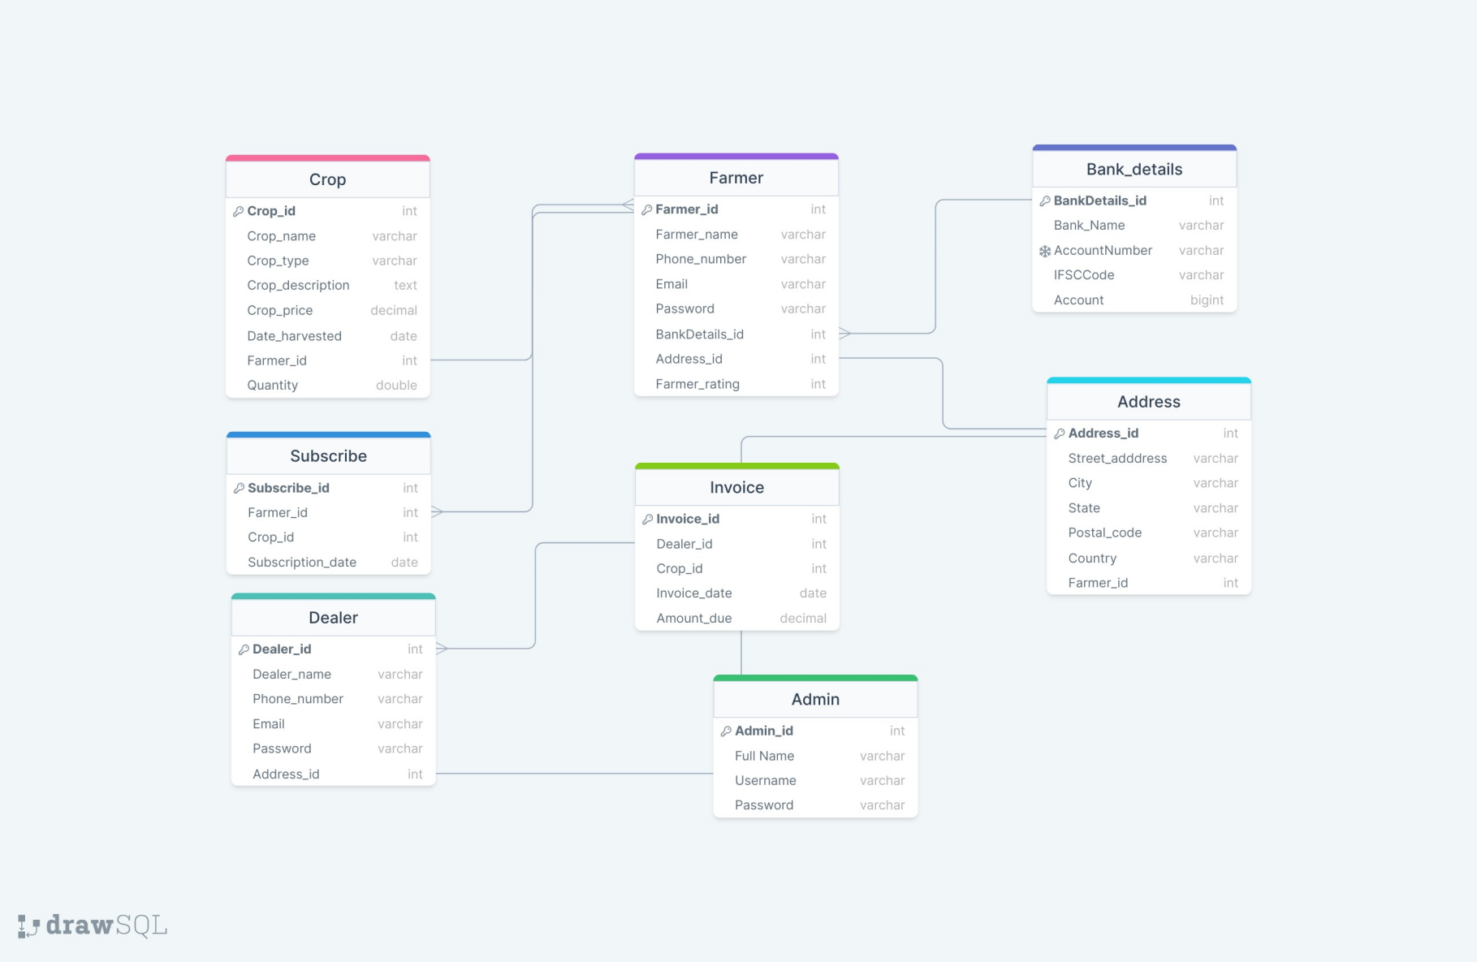

12